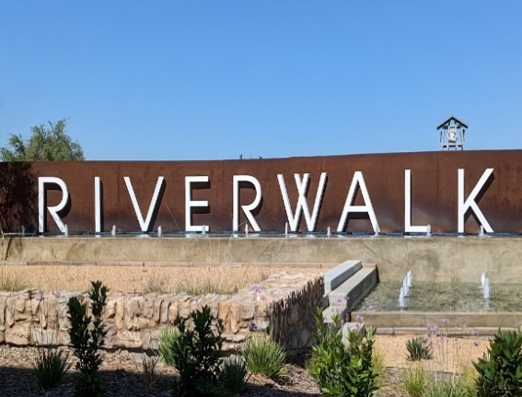
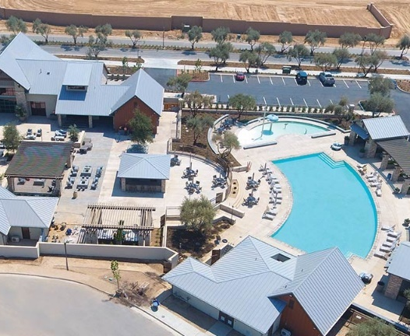

ROOT CREEK WATER DISTRICT
2022 Municipal
Rate Study Update

DRAFT REPORT
June 6, 2022

909 Marina Village Parkway #135
Alameda, CA 94501
(510) 545-3182
www.LTmuniconsultants.com

Table of Contents

Section 1: Introduction 1
1.1 Background 1
1.2 Requirements of Proposition 218 1
1.3 Rate Study Process 3
1.4 Summary of Proposed Rates 4
Section 2: Current Rates and Customer Base 7
2.1 Assessments 7
2.2 Municipal Rates 8
2.3 Historic Municipal Operating Results 9
2.4 Customer Base 10
2.5 Municipal Water Use 11
Section 3: Municipal Water Rates 12
3.1 Municipal Water Cash Flow Projection 13
3.2 Municipal Volume Rate Design 15
3.3 Current and Proposed Municipal Water Rates 17
Section 4: Sewer Rates 21
4.1 Sewer Cash Flow Projection 21
4.2 Sewer Rate Design 22
Section 5: Storm Drain Rates 24
5.1 Storm Drain Cash Flow Projection 24
5.2 Storm Drain Rate Design 25
Section 6: Proposed Municipal Rates and Operating Results 26
6.1 Proposed Municipal Rates 26
6.2 Operating Results 29

list of Tables

Table 1: Current and Proposed Bimonthly Rates 4
Table 2: Proposed Bimonthly Volume Rates – Drought Conditions 5
Table 3: Municipal and Agricultural Assessments 7
Table 4: Current and Historical Municipal Bimonthly Rates 8
Table 5: Outstanding Municipal Operating Debt 9
Table 6: Estimated Billing Unit Projection 10
Table 7: Meter Equivalents 11
Table 8: 2022 Assessment Revenues and Expenses 12
Table 9: Municipal Water Service Operating Cash Flow 14
Table 10: Historical Water Costs 16
Table 11: MID and Wonderful Historical Water Costs 16
Table 12: 2022 Volume Rate Design 17
Table 13: Current and Proposed Municipal Bimonthly Water Rates 18
Table 14: Proposed Bimonthly Volume Rates – Drought Conditions 18
Table 15: Sewer Service Operating Cash Flow 22
Table 16: Storm Drain Operating Cash Flow 25
Table 17: Current and Proposed Municipal Bimonthly Rates 26
Table 18: Proposed Bimonthly Volume Rates – Drought Conditions 27
Table 19: Municipal Operating Results 29

list of figures

Figure 1: Comprehensive Cost of Service Study Process 3
Figure 2: Bimonthly Utility Bill Survey - Water and Sewer 5
Figure 3: Bimonthly Utility Bill Survey Based on Community Characteristics 6
Figure 4: Bimonthly Average Single Family Water Use 11
Figure 5: Bimonthly Water Bill Survey 19
Figure 6: RCWD, Fresno, and Clovis Comparison 20
Figure 7: Bimonthly Sewer Bill Survey 23
Figure 8: Bimonthly Utility Bill Survey - Water and Sewer 27
Figure 9: Bimonthly Utility Bill Survey Based on Community Characteristics 28
Figure 10: Municipal Operating Debt 30

Introduction

Background
The Root Creek Water District (Root Creek WD, RCWD, or District) was formed in 1996 to address the declining groundwater table in southeastern Madera County and to ensure a long term reliable water supply for all water users within RCWD. Although Root Creek WD was formed in 1996, only its agricultural water supply powers were used until the District applied to the Madera County Local Agency Formation Commission to activate RCWD’s latent powers to provide municipal services for the Riverstone Development in 2013. Root Creek WD now provides agricultural water service to about 8,150 acres and municipal (potable) water service, wastewater service, and storm drain service to about 1,000 customers.
Agricultural and municipal customers benefit from RCWD’s fully sustainable water supply. In 2007, RCWD secured surface water supply sufficient to reverse the groundwater deficit for the entire District. Concurrently, RCWD developed a sustainable water management plan that satisfies the substantive components of a local Groundwater Sustainability Plan (GSP) required by the Sustainable Groundwater Management Act (SGMA). To fulfill the District's commitment to balance the groundwater supply to support all current and projected water uses, RCWD attained long‐term water supply, storage, and conveyance (or "wheeling”) contracts. The District’s sustainable water supply portfolio is decades ahead of many other areas in the state that are still in groundwater overdraft.
The District last completed a Rate Study and Financial Plan in 2016. That plan, which was approved by landowners in the District, determined a Community Facilities District tax, connection fees, utility rates, and charges to fairly recover costs for agricultural water service and municipal utility services for the Riverstone Development. In 2022, the Root Creek Water District engaged Lechowicz & Tseng Municipal Consultants to complete a municipal water, wastewater (sewer), and storm drain rate study update to recommend increased rates to promote the financial health and stability of the District’s enterprise funds. The study period covers the five-year period beginning in 2022 through 2026. This report serves to document the proposed rates for municipal water, wastewater, and storm drain services.

Requirements of Proposition 218
The implementation of utility rates in California are governed by the substantive and procedural requirements of Proposition 218, the “Right to Vote on Taxes Act,” which is codified as Articles XIIIC and XIIID of the California Constitution. The District must follow the procedural requirements of Proposition 218 for all utility rate increases. These requirements include:
- Noticing Requirement – The District must mail a notice of the proposed rate increases to all affected property owners or ratepayers. The notice must specify the amount of the fee, the basis upon which it was calculated, the reason for the fee, and the date/time/location of a public rate hearing at which the proposed rates will be considered/adopted.

- Public Hearing – The District must hold a public hearing prior to adopting the proposed rate increases. The public hearing must be held not less than 45 days after the required notices are mailed.
- Rate Increases Subject to Majority Protest – At the public hearing, the proposed rate increases are subject to majority protest. If more than 50% of affected property owners or ratepayers submit written protests against the proposed rate increases, the increases cannot be adopted.
Proposition 218 also established substantive requirements that apply to water, sewer, and storm drain rates and charges, including:

- Cost of Service – Revenues derived from the fee or charge cannot exceed the funds required to provide the service. In essence, fees cannot exceed the “cost of service”.
- Intended Purpose – Revenues derived from the fee or charge can only be used for the purpose for which the fee was imposed.
- Proportional Cost Recovery – The amount of the fee or charge levied on any customer shall not exceed the proportional cost of service attributable to that customer.
- Availability of Service – No fee or charge may be imposed for a service unless that service is used by, or immediately available to, the owner of the property.
- General Government Services – No fee or charge may be imposed for general governmental services where the service is available to the public at large.
Charges for water, sewer, and storm drain collection are exempt from additional voting requirements of Proposition 218, provided the charges do not exceed the cost of providing service and are adopted pursuant to the procedural requirements of Proposition 218.

Rate Study Process
This section details the development of the District’s water, sewer, and storm drain rates via the Proposition 218 process as shown in the following figure.
Figure 1: Comprehensive Cost of Service Study Process

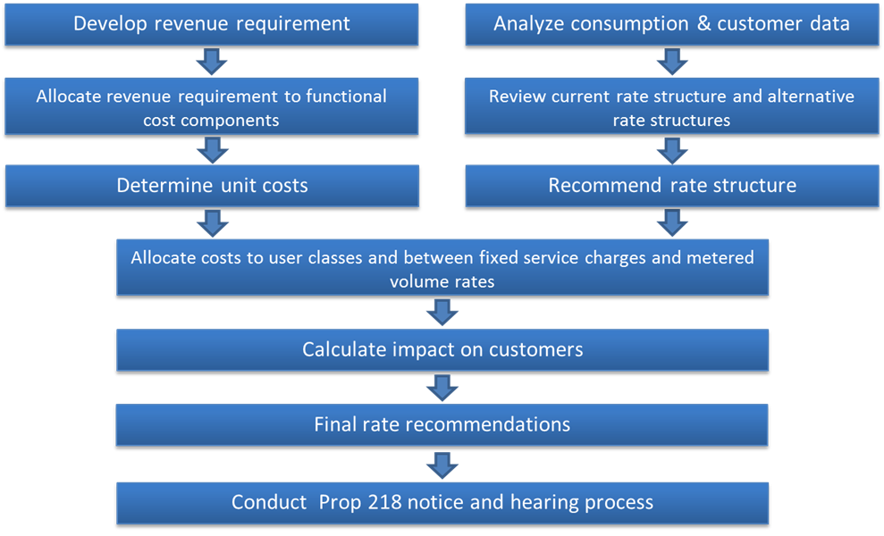

The following is a brief description of the rate study process:

- Revenue Requirements - Revenue requirements are analyzed via financial plans developed from the District’s budgets. Based on the best information currently available, the financial plans incorporate projected operation and maintenance costs, capital expenditures, debt service, and growth to estimate annual revenue requirements. The plans serve as a roadmap for funding the District’s operations while maintaining long-term fiscal stability.

- Cost of Service Allocation - The cost of service process builds on the financial plan analysis and assigns water, sewer, and storm drain system costs to functional cost components.

- Rate Design - Rate design involves developing a rate structure that proportionately recovers costs from customers. Final rate recommendations are designed to (a) fund the utilities’ short- and long-term costs of providing service; (b) proportionately allocate costs to all customers and customer classes; and (c) comply with the substantive requirements of Proposition 218.
The rates developed in this report were based on the best available information gathered from District budgets, audits, and input from staff. The proposed rates are based on the reasonable cost of providing service and are proportional to the benefits received by each customer.

Summary of Proposed Rates
The updated water, sewer, and storm drain proposed rates were developed to fairly recover costs, adhere to California statute, and be affordable to customers. Current and proposed bimonthly rates are provided in Table 1. The first rate increase is proposed to go into effect September 1, 2022, and future rate adjustments are proposed to go into effect January 1 each year thereafter. The total combined equivalent assessment, water, sewer, and storm drain bill for a typical single family home on a 1/5 acre lot using 25 hundred cubic feet (CCF) of water per bimonthly billing period is proposed to increase from $138.15 to $172.98 on September 1, 2022. It is proposed that the current municipal land assessment of $35.81 per acre no longer be billed separately. The equivalent cost will be incorporated into the water charges.

Table 1: Current and Proposed Bimonthly Rates
2022 Municipal Rate Study Update
Root Creek Water District
Category | January 1,  2022 Current | September 1, 2022 | January 1, 2023 | January 1, 2024 | January 1, 2025 | January 1, 2026
Municipal Water Service
Residential Volume Rates ($/CCF)
Tier 1: 0 to 20 CCF | $1.55 | $1.98 | $2.48 | $3.10 | $3.35 | $3.62
Tier 2: over 20 CCF | $2.18 | $2.91 | $3.64 | $4.55 | $4.91 | $5.30
Non-residential Volume Rate ($/CCF)
Commercial |  | $2.32 | $2.90 | $3.63 | $3.92 | $4.23
Irrigation |  | $2.37 | $2.96 | $3.70 | $4.00 | $4.32
Meter Fees
1" | $37.90 | $47.38 | $59.23 | $74.04 | $79.96 | $86.36
1.5" | $37.90 | $47.38 | $59.23 | $74.04 | $79.96 | $86.36
2" | $59.44 | $75.81 | $94.77 | $118.46 | $127.94 | $138.18
3" | $116.74 | $151.62 | $189.54 | $236.93 | $255.87 | $276.35
4" | $181.22 | $236.90 | $296.15 | $370.20 | $399.80 | $431.80
6" | $360.34 | $473.80 | $592.30 | $740.40 | $799.60 | $863.60
Municipal Sewer Service
Per Dwelling Unit | $50.00 | $62.50 | $78.13 | $97.66 | $117.19 | $140.63
Municipal Storm Drain Service
Per Dwelling Unit | $7.16 | $8.95 | $11.19 | $13.99 | $17.49 | $20.11
Assessment ($/acre/year) | $35.81 | No longer billed – incorporated into water rates shown above

The proposed rate structure also includes drought rates, which are provided in Table 2. In the event of a drought, all customers will continue to be billed the same meter fees, but will be billed the residential tier 2 volume rate for all water use. The tier 2 residential rate is equal to the highest cost of water the District purchases (Madera Irrigation District and Wonderful Nut Orchard supply). Under drought conditions, lower cost water will not be available. Drought rates will apply following a formal declaration of a drought and/or drought conditions by the RCWD Board of Directors.

Table 2: Proposed Bimonthly Volume Rates – Drought Conditions
2022 Municipal Rate Study Update
Root Creek Water District
Category | September 1, 2022 | January 1, 2023 | January 1, 2024 | January 1, 2025 | January 1, 2026
Municipal Water Volume Rates ($/CCF) – Drought Conditions
Residential | $2.91 | $3.64 | $4.55 | $4.91 | $5.30
Commercial | $2.91 | $3.64 | $4.55 | $4.91 | $5.30
Irrigation | $2.91 | $3.64 | $4.55 | $4.91 | $5.30

A survey comparing Root Creek WD’s proposed September 1, 2022, water and sewer rates for a typical single family residential customer with the rates charged by local utilities is provided in Figure 2. Many agencies do not charge storm drain fees, so storm drain charges are not included in the bill survey. A typical single family customer in Riverstone resides on a 1/5 acre lot, is served by up to a 1 ½‐inch water meter, and consumes 25 CCF of water bimonthly. The survey calculates typical bills based on the 1-inch meter size for comparable agencies.
Figure 2: Bimonthly Utility Bill Survey - Water and Sewer

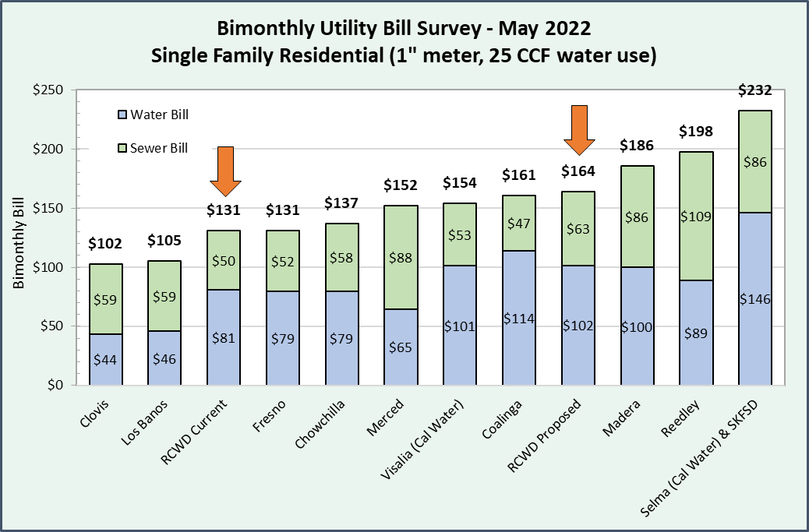
Please see Figure 5 and Figure 7 for more detailed rate information of the comparable agencies.
Figure 3 provides a survey comparing the current and proposed water and sewer bills of Root Creek Water District to the Cities of Fresno and Clovis. The Fresno and Clovis bills are based on the average per capita water usage and household size for those communities.

Figure 3: Bimonthly Utility Bill Survey Based on Community Characteristics

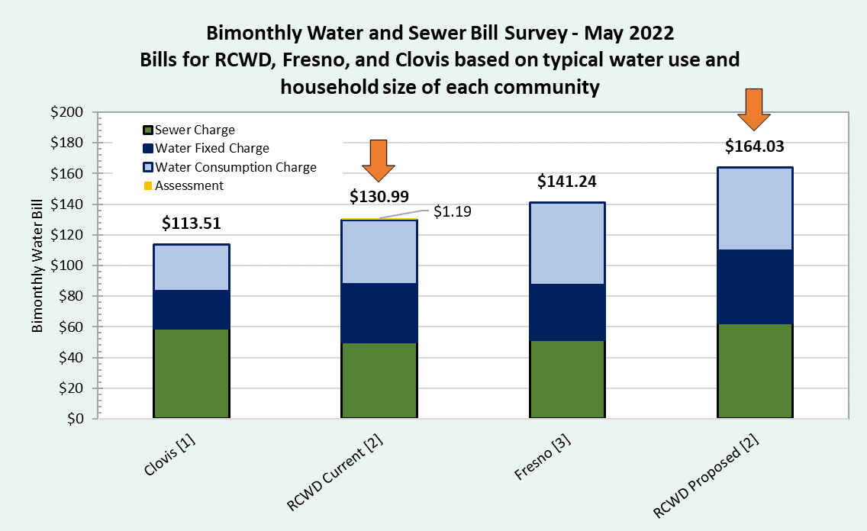

[1] Rate shown is based on bimonthly water use of 27 thousand gallons (36.2 CCF). According to 2021 data from the State Water Resources Control Board, average residential daily usage per capita is 149.58 gallons per day in the City of Clovis, which equates to 12.2 CCF bimonthly. Based on 2020 Census data, the average household size is 2.97 people per home in Clovis, meaning usage per household is approximately 36.2 CCF bimonthly.
[2] Rate shown is based on bimonthly water use of 25 CCF.
[3] Rate shown is based on bimonthly water use of 31 CCF. According to 2021 data from the State Water Resources Control Board, average residential daily usage per capita is 126.36 gallons per day in the City of Fresno, which equates to 10.3 CCF bimonthly. Based on 2020 Census data, average household size in Fresno is 3.04 people per home, meaning usage per household is approximately 31 CCF bimonthly.

Current Rates and Customer Base
This section describes Root Creek Water District’s current rates and projected customer base over the next five years.

Assessments
Currently, RCWD charges a land assessment of $35.81 per acre and expects to collect about $342,000. Of the 2022 assessment revenue, about $50,000 is attributed to municipal land use. For the ease of billing, the District prefers the equivalent municipal assessment revenue be collected via bimonthly rates into the future. The agricultural land assessments will continue to be billed annually. Table 3 provides the current and projected municipal and agricultural acreage count through 2026. It is estimated that about 1,060 acres will be developed from agricultural use to municipal use.

Table 3: Municipal and Agricultural Assessments
2022 Municipal Rate Study Update
Root Creek Water District
 | 2022 | 2023 | 2024 | 2025 | 2026
Agricultural Acres | 8,150 | 7,550 | 7,250 | 7,090 | 7,090
Municipal Acres | 1,400 | 2,000 | 2,300 | 2,460 | 2,460
Total Acres | 9,550 | 9,550 | 9,550 | 9,550 | 9,550
Agricultural Land Assessments | $291,852 | $278,444 | $275,428 | $277,432 | $285,727
Municipal Land Assessments | $50,134 | $0 | $0 | $0 | $0
Municipal Admin Cost Recovery [1] | $0 | $73,760 | $87,377 | $96,260 | $99,138
Total Assessment Revenue (+3%/yr) | $341,986 | $352,204 | $362,805 | $373,692 | $384,865
1 – Municipal land assessments are proposed to be discontinued. District administrative costs that were previously recovered through municipal assessments are proposed to be recovered via bimonthly utility rates.

Municipal Rates
Table 4 provides RCWD’s municipal water, sewer, and storm drain rates from 2016 to current.

Table 4: Current and Historical Municipal Bimonthly Rates
2022 Municipal Rate Study Update
Root Creek Water District
Category | June 1, 2016 | January 1, 2018 | February 11, 2019 | January 1, 2020 | January 1, 2021 | January 1, 2022 Current
Municipal Water Service
Volume Rates ($/CCF)
Tier 1: 0 to 20 CCF | $1.30 | $1.38 | $1.42 | $1.46 | $1.50 | $1.55
Tier 2: over 20 CCF | $1.83 | $1.94 | $2.00 | $2.06 | $2.12 | $2.18
Meter Fees
1" | $32.00 | $33.82 | $34.78 | $35.76 | $36.80 | $37.90
1.5" | $32.00 | $33.82 | $34.78 | $35.76 | $36.80 | $37.90
2" | $50.00 | $52.92 | $54.46 | $56.02 | $57.70 | $59.44
3" | $98.00 | $103.84 | $106.90 | $110.04 | $113.34 | $116.74
4" | $152.00 | $161.14 | $165.90 | $170.82 | $175.94 | $181.22
6" | $302.00 | $320.28 | $329.82 | $339.66 | $349.84 | $360.34
Municipal Sewer Service
Per Dwelling Unit | $50.00 | $50.00 | $50.00 | $50.00 | $50.00 | $50.00
Municipal Storm Drain Service
Per Dwelling Unit | $6.00 | $6.36 | $6.56 | $6.76 | $6.96 | $7.16

The District’s current water rate structure includes two components: (a) a Fixed Charge and (b) Volume Rates. All customers are charged the same fixed charge regardless of water consumption to reflect that even when a customer does not use any water, the District incurs fixed costs associated with maintaining the ability or readiness to serve each connection. Fixed costs include management, clerical, legal, operations, and miscellaneous cost categories. RCWD is also obligated to import a minimum amount of water as part of its groundwater management plan.

For municipal water service, an EDU is defined as a single family residential customer (four people per home) served by a 1 ½‐inch meter. Historically, single family residential customers in California have been served by 5/8‐inch or ¾‐inch connections. However, most new single family residential connections in Root Creek WD will be served by 1 ½‐inch meters to provide adequate pressure. All meter sizes up to the 1 ½‐inch meters are considered one EDU and are charged the 1 ½‐inch meter fee.

In addition to the fixed charge, all customers pay volume rates per CCF of metered water consumption. One CCF is equal to 748 gallons of water. The volume rates have an inclining tiered rate structure for residential customers, meaning that at higher levels of water use, customers pay a higher rate per unit. This type of rate structure is appropriate for water purveyors such as Root Creek WD with multiple sources of supply that are priced differently. Tier 1 encompasses the first 20 CCF of water use in the bimonthly billing period and is charged $1.55 per CCF. Consumption above tier 1 is charged $2.18 per CCF. The tiered rates are charged to all customers including commercial and irrigation meters.

Municipal sewer and storm drain rates are charged on an equivalent dwelling unit basis. The fees for non-residential customers are assigned an equivalent dwelling unit count based on their flows and pollutant loading for the sewer rates and based on impervious area for the storm drain rates. It is assumed that one EDU is a medium density, single family home on a 1/5 acre parcel.

Historic Municipal Operating Results
Since their inception, the municipal utilities have operated at a deficit, reflecting high fixed costs that could not be fully recovered from a small customer base. Deficit spending has been funded by the Riverstone landowner. This rate study develops a plan for repayment obligations. It is assumed that the municipal utilities will continue to operate at a deficit through 2023. In 2024, with the rate increases recommended herein plus growth of RCWD’s customer base, the utilities are projected to generate positive net revenues and begin repayment. Table 5 summarizes the operating debt of each of the three municipal utilities as of January 1, 2022. The amounts shown below are used as the beginning fund balance in each utility’s cash flow.
Table 5: Outstanding Municipal Operating Debt
2022 Municipal Rate Study Update
Root Creek Water District
Expense | Muni Water | Sewer | Storm Drain | Total
Past District Formation Costs | $6,327,726 | $0 | $0 | $6,327,726
Less Amount Paid from Connection Fees or CFD Taxes | ($5,851,400) | $0 | $0 | ($5,851,400)
Wonderful Standby Charge | $561,411 | $0 | $0 | $561,411
2015-17 Operating Costs | $1,036,131 | $267,641 | $4,220 | $1,307,992
MID Rooftop Fees | $114,753 | $0 | $0 | $114,753
Billing for MID | $50,000 | $0 | $0 | $50,000
Billing for Annual Property Assessment | $4,481 | $0 | $0 | $4,481
Billing for Meter Installation | $9,434 | $0 | $0 | $9,434
Operating Deficits 2018 to 2021 | $2,203,747 | $874,336 | $119,109 | $3,197,191
Total Amount Owed | $4,456,282 | $1,141,977 | $123,329 | $5,721,588

Customer Base
Table 6 shows an estimate of meter counts, water use, and sewer and storm drain EDUs over the five-year rate study period. The District estimates a significant amount of residential growth as the Riverstone Development is constructed.

The water utility has about 965 active meters. Table 7 calculates the estimated 2021 meter equivalents. Larger water meters are scaled to the size of the 1 ½-inch meter based on the American Water Works Association recommended meter ratios, which are proportional to the maximum demand available to each meter size. In total, the water system serves about 1,015 meter equivalents. Over 94% of meters served are the base meter size of 1 ½-inch.

Table 6: Estimated Billing Unit Projection
2022 Municipal Rate Study Update
Root Creek Water District
Billing Units | 2021 | 2022 | 2023 | 2024 | 2025 | 2026
Meter Count
1”/1.5” | 909 | 1,449 | 1,989 | 2,389 | 2,789 | 3,189
2” | 54 | 57 | 60 | 63 | 66 | 69
3” | 0 | 0 | 0 | 0 | 0 | 0
4” | 0 | 0 | 0 | 0 | 0 | 0
6” | 2 | 2 | 2 | 2 | 2 | 2
 | 965 | 1,508 | 2,051 | 2,454 | 2,857 | 3,260
Meter Equivalents | 1,015 | 1,560 | 2,105 | 2,510 | 2,915 | 3,319
Midpoint |  | 1,288 | 1,833 | 2,307 | 2,712 | 3,117
Residential Water Sales (CCF)
Tier 1: 0 to 20 CCF | 75,672 | 125,321 | 174,969 | 211,746 | 248,523 | 285,300
Tier 2: over 20 CCF | 41,252 | 68,311 | 95,369 | 115,412 | 135,455 | 155,498
Total | 116,925 | 193,631 | 270,338 | 327,158 | 383,978 | 440,798
Midpoint Residential Water Sales (CCF)
Tier 1: 0 to 20 CCF |  | 100,497 | 150,145 | 193,358 | 230,134 | 266,911
Tier 2: over 20 CCF |  | 54,781 | 81,840 | 105,390 | 125,434 | 145,477
Total |  | 155,278 | 231,985 | 298,748 | 355,568 | 412,388
Commercial Water Sales (CCF) |  | 10,970 | 11,330 | 11,690 | 12,050 | 12,410
Midpoint |  | 10,970 | 11,150 | 11,510 | 11,870 | 12,230
Irrigation Water Sales |  | 49,764 | 49,764 | 49,764 | 49,764 | 49,764
Sewer EDUs | 855 | 1,426 | 1,966 | 2,366 | 2,766 | 3,166
Midpoint |  | 1,141 | 1,696 | 2,166 | 2,566 | 2,966
Storm Drain EDUs | 855 | 1,479 | 2,019 | 2,419 | 2,819 | 3,219
Midpoint |  | 1,167 | 1,749 | 2,219 | 2,619 | 3,019

Table 7: Meter Equivalents
2022 Municipal Rate Study Update
Root Creek Water District
Meter Size | Meter Equivalent [1] |  | Count of Meters 2021 |  | Total Meter Equivalents 2021
1"/1.5" | 1.0 | x | 909 | = | 909.0
2" | 1.6 | x | 54 | = | 86.4
3" | 3.2 | x | 0 | = | 0.0
4" | 5.0 | x | 0 | = | 0.0
6" | 10.0 | x | 2 | = | 20.0
 |  |  | 965 |  | 1,015.4
1 – Based on maximum flow rate of each meter size

Municipal Water Use
As shown in Table 6, about two thirds of bimonthly residential water use occurs in tier 1 and about one third occurs in tier 2. Average annual bimonthly water use is 25 CCF (shown as the orange line in Figure 4). Lowest average winter bimonthly use is about 15 CCF and highest summer use is about 34 CCF. Water use of commercial and industrial customers (excluding the school) was analyzed and only about 10% of non-residential use falls in tier 1 and 90% occurs in tier 2.

Figure 4: Bimonthly Average Single Family Water Use

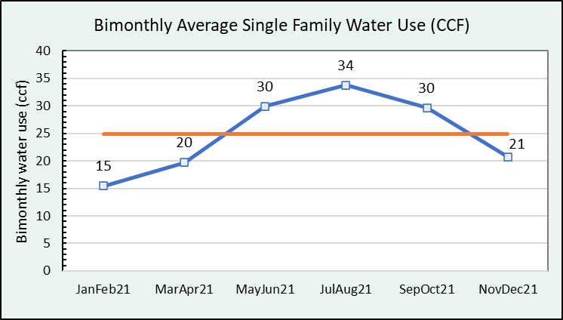

Municipal Water Rates
This section describes rate updates proposed for the municipal water service. As a first step, the cost of service is established. As discussed, RCWD recovers its cost of service from assessments as well as rates. Increased assessments were approved by landowners within the District in February 2016 to cover the estimated costs of groundwater monitoring and District administration. Since 2016, RCWD has established a detailed operating budget based on actual costs. Table 8 identifies budget categories and costs that are proposed to be recovered from assessment revenues. As agricultural land is developed into municipal land, the municipal water utility will fund a greater proportional share of the costs shown below. The five-year rate plan established in this report assumes that the agricultural water service will continue to recover the costs shown below via assessments and that the municipal water service will recover these costs via rates.

Table 8: 2022 Assessment Revenues and Expenses
2022 Municipal Rate Study Update
Root Creek Water District
Assessments |  |  | Revenues
Municipal Land Assessments |  |  | $50,134
Agricultural Land Assessments |  |  | $291,852
 |  |  | $341,986
Budget Code | Enterprise | Description | Expenses
660 | 01-District Admin | General & Administrative Costs | $27,500
640.01 | 01-District Admin | Membership dues | $5,000
620.05 | 01-District Admin, 02-Water, 05-Ag [1] | Legal | $35,000
620.03 | 01-District Admin | Management | $20,000
630.04 | 02-Water and 05-Agriculture | GSP | $25,000
620.09 | 02-Water and 05-Agriculture | Special Counsel | $100,000
610.02 | 02-Water and 05-Agriculture | Website | $6,500
570 | 02-Water and 05-Agriculture | Groundwater Maintenance | $25,000
620.06 | 02-Water and 05-Agriculture | GIS Services | $25,000
620.03 | 02-Water and 05-Agriculture Portion [1] | Management | $67,500
650.01 | 02-Water and 05-Agriculture Portion [1] | Insurance | $5,000
 |  |  | $342,000
1 - The sewer and storm drain enterprises also have expenses under these line items that are not included in the costs shown here. Sewer and storm drain costs are proposed to be funded solely from rate revenues.

Municipal Water Cash Flow Projection
The municipal water cost of service includes a portion of District administrative costs, metering costs, operating costs, and the purchase of imported water. Most cost categories are assumed to increase by 3% annually. Lab analysis, repairs, and chemicals are assumed to increase proportional to growth in RCWD’s customer base. Moreover, power costs are expected to increase by a greater extent due to known rate increases from Pacific Gas & Electric in addition to system growth. Water importation costs are assumed to increase by 5% annually.
The 2022 operating fund balance is negative $4.46 million reflecting past deficit spending (see Table 5) which is projected to increase by $1.455 million through 2023. Deficit funding will be advanced by the landowner, who will be repaid via water rate revenues beginning in 2024. During the early years of the Riverstone Development, there are fewer rate‐paying customers. As more customers connect to the water system and begin paying rates, the utility’s revenues will increase and the municipal water system is projected to cover costs and begin repaying the landowner. Table 9 provides the cash flow for the municipal water service. It is projected that the water utility will repay the landowner $1.5 million through 2026.
It is recommended that the District adopt 25% revenue increases for the first three years of the five-year rate study period. It is assumed that the first rate increase will go into effect September 1, 2022. However, subsequent rate increases will go into effect January 1 of each year thereafter. The proposed rate increases for 2025 and 2026 are 8%. 8% rate adjustments compounded with customer growth are projected to generate net positive revenues to cover operating costs and repay the landowner. Absent a rate increase, the water utility would continue to operate at a deficit and accrue a large obligation to the landowner.
With the September 1, 2022, rate change, not all customers will receive the same bill increases due to the re-configuration of the rate structure’s volume rates. The rate change for each customer will depend on customer class and water usage. Following the September 1, 2022, rate change, all customers will receive the same percent increase.

Table 9: Municipal Water Service Operating Cash Flow
2022 Municipal Rate Study Update
Root Creek Water District
 | 2022 | 2023 | 2024 | 2025 | 2026
Date of Rate Change | 1-Sep | 1-Jan | 1-Jan | 1-Jan | 1-Jan
Rate Change [1] | 25% | 25% | 25% | 8% | 8%
BEGINNING FUND BALANCE | (4,456,300) | (5,418,800) | (5,911,300) | (5,828,800) | (5,355,800)
REVENUES
Assessments | 50,100 | 0 | 0 | 0 | 0
Rate Revenue | 695,800 | 1,501,200 | 2,329,900 | 2,933,600 | 3,619,100
Hydrant Water | 30,400 | 38,000 | 47,500 | 51,300 | 55,400
Inspection Fees | 117,000 | 120,500 | 124,100 | 127,800 | 131,600
TOTAL REVENUES | 893,300 | 1,659,700 | 2,501,500 | 3,112,700 | 3,806,100
EXPENSES
Administration [2] | 50,100 | 73,800 | 87,400 | 96,300 | 99,100
Customer Service (Contracted) | 103,000 | 113,300 | 124,600 | 137,100 | 150,800
Municipal Operations
Operator | 200,000 | 206,000 | 212,200 | 218,600 | 225,200
Permits and Inspections | 121,300 | 124,900 | 128,600 | 132,500 | 136,500
Professional Services | 51,400 | 52,900 | 54,500 | 56,100 | 57,800
Rate Study & Financial Planning | 19,000 | 0 | 0 | 0 | 0
Engineering & Master Planning | 58,800 | 60,600 | 62,400 | 64,300 | 66,200
Repairs | 25,000 | 39,100 | 53,200 | 63,700 | 74,200
Lab Analysis | 10,000 | 15,600 | 21,200 | 25,400 | 29,600
Power | 212,200 | 397,900 | 541,200 | 647,500 | 753,800
Chemicals | 25,000 | 39,100 | 53,200 | 63,700 | 74,200
Total Admin and Operations | 875,800 | 1,123,200 | 1,338,500 | 1,505,200 | 1,667,400
Water Importation Cost | 980,000 | 1,029,000 | 1,080,500 | 1,134,500 | 1,191,200
TOTAL EXPENSES | 1,855,800 | 2,152,200 | 2,419,000 | 2,639,700 | 2,858,600
NET REVENUES | (962,500) | (492,500) | 82,500 | 473,000 | 947,500
ENDING FUND BALANCE | (5,418,800) | (5,911,300) | (5,828,800) | (5,355,800) | (4,408,300)
1 – The September 1, 2022 rate change reflects a +25% increase of fixed charges and a re-configuration of the volume rates. In subsequent years, rate changes reflect the increases shown.
2 – The municipal water system’s share of administrative costs that were formerly recovered from assessments

Municipal Volume Rate Design
Proposition 218 requires that agencies providing “property-related services” (including water utility service) set rates and charges that are based on the cost of providing those services and are proportional to how customers use the system. It is proposed that RCWD maintain the same rate structure with two tiers of water volume rates in addition to fixed meter charges for residential customers. It is proposed that the lower cost tier equal the average cost of the District’s supply over the past five years and the higher cost tier equal the cost of the District’s most expensive sources of supply – water from Wonderful Nut Orchard and Madera Irrigation District (MID). Historical water costs and total water diverted are provided in Table 10 and Table 11.

As shown in Table 10, the MID and Wonderful Nut Orchard water supply represents about 1/3 of historical supply over the past 5 years (6,000 AF / 17,610 AF). Thus, the higher cost tier and associated water use in that tier is proposed to encompass the top 1/3 of water use for residential customers. This level of use closely aligns with RCWD’s current rate structure in which the first tier is 0 to 20 CCF bimonthly consumption and covers about 65% of annual residential water use. The higher tier for use above 20 CCF encompasses about 35% of annual residential use.

Going forward, it is proposed that customers be divided into three customer classes—residential, commercial, and landscape irrigation. Residential customers will continue to be charged according to the existing two-tiered rate structure while commercial and irrigation customers will be charged a uniform tier volume rate through which all use is charged at the same rate. Currently, only 10% of non-residential water use falls within the first water rate tier and 90% falls in tier 2. Non-residential water use is greater than projected in the 2016 rate study and the current tier structure does not reflect typical commercial and irrigation usage patterns. Based on recent billing records, commercial customers have a peaking factor of about 1.6 and irrigation customers have a peaking factor of about 1.7. These peaking factors are used to assign the higher cost of MID and Wonderful Nut Orchard water supply to non-residential customers.

Table 12 calculates the proposed 2022 water rates for residential, commercial, and irrigation customers. The cost of power and chemicals is calculated as $1.10 per CCF of water delivered to customers and is added to the water supply cost. Because commercial and irrigation customers are no longer subject to a tiered rate system, their uniform volume rates are calculated as the weighted average of peak and non-peak supply.

The proposed volume rates also include drought rates. In the event of a drought, it is proposed that all customers be charged a uniform volume rate equivalent to the tier 2 rate for residential use under ordinary conditions. Tier 2 represents the highest cost water the District would need to purchase due to water shortages (Madera Irrigation District and Wonderful Nut Orchard supply). Under drought conditions, lower cost water will not be available. Drought rates will apply following a formal declaration of a drought and/or drought conditions by the RCWD Board of Directors.

Table 10: Historical Water Costs
2022 Municipal Rate Study Update
Root Creek Water District
 | Supply (AF) |  |  |  | Cost ($) |  |  |  |  |  | Yearly Water Cost
Year | Total Water Diverted | 215 / uncontrolled | MID | Wonderful | MID | Wonderful |  | Total |  |  | $/AF |  | $/CCF
2017 | 6,814 | 6,814 | - | - | $923,060 |  |  | $923,060 |  |  | $135.47 |  | $0.31
2018 | 1,361 | 611 | - | 750 | $94,250 | $699,110 |  | $793,360 |  |  | $582.92 |  | $1.34
2019 | 8,185 | 4,185 | 3,000 | 1,000 | $1,677,750 | $879,007 |  | $2,544,750 |  |  | $310.90 |  | $0.71
2020 | - | - | - | - | $100,000 | $1,018,393 |  | $1,118,393
2021 | 1,250 | - | - | 1,250 | $300,000 | $1,080,247 |  | $1,380,247 |  |  | $1,104.20 |  | $2.53
 | 17,610 | 11,610 | 3,000 | 3,000 | $3,095,060 | $3,676,758 |  | $6,759,811 |  |  | $383.86 |  | $0.88

Table 11: MID and Wonderful Historical Water Costs
2022 Municipal Rate Study Update
Root Creek Water District
 | Supply (AF) |  |  | Cost ($) |  |  |  |  |  | Yearly Water Cost
Year | Total Water Diverted | MID | Wonderful | MID | Wonderful |  | Total |  |  | $/AF |  | $/CCF
2018 | 750 | - | 750 | $94,250 | $699,110 |  | $793,360
2019 | 4,000 | 3,000 | 1,000 | $1,677,750 | $879,007 |  | $2,544,750
2021 | 1,250 | - | 1,250 | $300,000 | $1,080,247 |  | $1,380,247
 | 6,000 | 3,000 | 3,000 | $2,072,000 | $2,658,364 |  | $4,730,364 |  |  | $788.39 |  | $1.81

Table 12: 2022 Volume Rate Design
2022 Municipal Rate Study Update
Root Creek Water District
Customer Class | Water Use (CCF) | Water Importation | Power and Chemicals | Total
Residential Water Use
Tier 1 (0-20) | 100,497 | $0.88 | $1.10 | $1.98
Tier 2 (20+) | 54,781 | $1.81 | $1.10 | $2.91
Total Residential use | 155,278
Commercial Use [1] | 10,970 | $1.22 | $1.10 | $2.32
Irrigation Use [1] | 49,764 | $1.27 | $1.10 | $2.37
Total FY2022 [2] | 216,012 | $264,175 | $237,200 | $501,375
1 - Average cost rate based on commercial and irrigation usage statistics. The MID + Wonderful rate is applied to non-residential peak use and the average 5-year water cost is applied to non-residential non-peak use.
2 - Total if applied to 12 months; the first rate adjustment is intended to take effect September 1, 2022 and to apply to 4 months of water consumption

Current and Proposed Municipal Water Rates
The current and proposed municipal water rates are provided in Table 13. For the proposed 2022 rates, the meter fees are calculated by scaling the current base fee of $37.90 by the equivalent meter ratios shown in Table 7 and escalating the rates by 25%. The volume rates for 2022 are as shown in Table 12. In subsequent years, rates are escalated by the percent increases shown in the municipal water service cash flow projection. Proposed municipal drought rates are provided in Table 14. Under drought conditions, it is proposed that all customers be assessed the calculated volume rate for tier 2 residential use.

Table 13: Current and Proposed Municipal Bimonthly Water Rates
2022 Municipal Rate Study Update
Root Creek Water District
Category | January 1, 2022 Current | September 1, 2022 |  | January 1, 2023 |  | January 1, 2024 |  | January 1, 2025 |  | January 1, 2026
Municipal Water Service
Residential Volume Rates ($/CCF)
Tier 1: 0 to 20 CCF | $1.55 | $1.98 | +28% | $2.48 | +25% | $3.10 | +25% | $3.35 | +8% | $3.62 | +8%
Tier 2: over 20 CCF | $2.18 | $2.91 | +33% | $3.64 | +25% | $4.55 | +25% | $4.91 | +8% | $5.30 | +8%
Non-residential Volume Rate ($/CCF)
Commercial |  | $2.32 | new | $2.90 | +25% | $3.63 | +25% | $3.92 | +8% | $4.23 | +8%
Irrigation |  | $2.37 | new | $2.96 | +25% | $3.70 | +25% | $4.00 | +8% | $4.32 | +8%
Meter Fees
1" | $37.90 | $47.38 | +25% | $59.23 | +25% | $74.04 | +25% | $79.96 | +8% | $86.36 | +8%
1.5" | $37.90 | $47.38 | +25% | $59.23 | +25% | $74.04 | +25% | $79.96 | +8% | $86.36 | +8%
2" | $59.44 | $75.81 | +28% | $94.77 | +25% | $118.46 | +25% | $127.94 | +8% | $138.18 | +8%
3" | $116.74 | $151.62 | +30% | $189.54 | +25% | $236.93 | +25% | $255.87 | +8% | $276.35 | +8%
4" | $181.22 | $236.90 | +31% | $296.15 | +25% | $370.20 | +25% | $399.80 | +8% | $431.80 | +8%
6" | $360.34 | $473.80 | +31% | $592.30 | +25% | $740.40 | +25% | $799.60 | +8% | $863.60 | +8%

Table 14: Proposed Bimonthly Volume Rates – Drought Conditions
2022 Municipal Rate Study Update
Root Creek Water District
Category | September 1, 2022 | January 1, 2023 | January 1, 2024 | January 1, 2025 | January 1, 2026
Municipal Water Volume Rates ($/CCF) – Drought Conditions
Residential | $2.91 | $3.64 | $4.55 | $4.91 | $5.30
Commercial | $2.91 | $3.64 | $4.55 | $4.91 | $5.30
Irrigation | $2.91 | $3.64 | $4.55 | $4.91 | $5.30

The first rate change is proposed to take effect September 1, 2022. For the typical single family residential customer on a 1/5 acre lot using 25 CCF and served by up to a 1 ½-inch meter, the bimonthly water bill will increase from $80.99 (including the assessment) to $101.53 (no assessment). The survey calculates typical bills based on the 1-inch meter size for comparable agencies.

Figure 5: Bimonthly Water Bill Survey

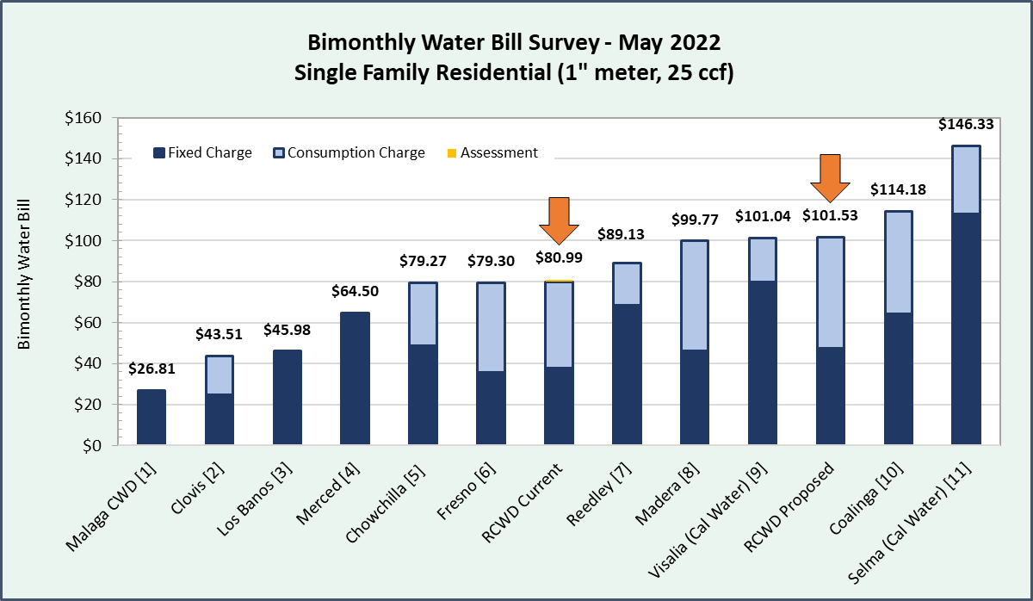

[1] New water rate study that will update rates began August 2021. Proposed rates are not yet available.
[2] Rates effective 7/1/2021
[3] Rates effective 7/1/2021
[4] Rates effective 7/1/2021
[5] Rate shown is proposed for FY 2023 based on most recent rate study dated April 22, 2020
[6] Rates effective 7/1/2021
[7] Rates effective 7/1/2021
[8] Rate shown is proposed for FY 2023 but not yet approved. Proposed rates will be voted on at Prop 218 Hearing scheduled for June 15, 2022
[9] Rate shown is proposed for 1/1/2023 but not yet approved
[10] Rate shown is planned to take effect 11/1/2022 based on rate schedule approved November 1, 2020
[11] Rate shown is proposed for 1/1/2023 but not yet approved

Figure 6 below compares the typical bimonthly residential water bills in Root Creek Water District, the City of Fresno, and the City of Clovis using the typical average residential usage for each agency. Based on data from the State Water Resources Control Board and the Census, the average residential water usage is approximately 36 CCF bimonthly in the City of Clovis and 31 CCF bimonthly in the City of Fresno, compared with 25 CCF bimonthly in the Root Creek Water District.
Figure 6: RCWD, Fresno, and Clovis Comparison

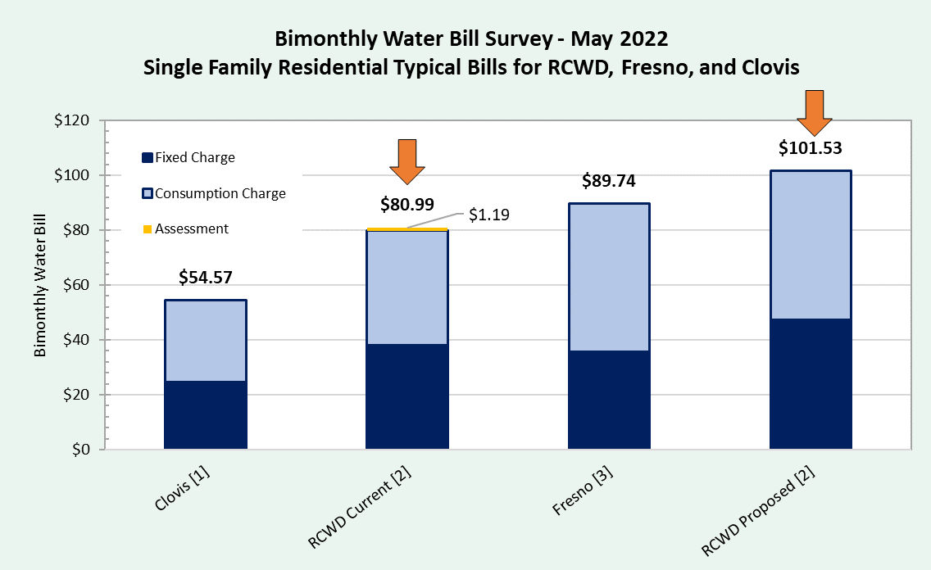

[1] Rate shown is based on bimonthly water use of 27 thousand gallons (36.2 CCF). According to 2021 data from the State Water Resources Control Board, average residential daily usage per capita is 149.58 gallons per day in the City of Clovis, which equates to 12.2 CCF bimonthly. Based on 2020 Census data, the average household size is 2.97 people per home in Clovis, meaning usage per household is approximately 36.2 CCF bimonthly.
[2] Rate shown is based on bimonthly water use of 25 CCF.
[3] Rate shown is based on bimonthly water use of 31 CCF. According to 2021 data from the State Water Resources Control Board, average residential daily usage per capita is 126.36 gallons per day in the City of Fresno, which equates to 10.3 CCF bimonthly. Based on 2020 Census data, average household size in Fresno is 3.04 people per home, meaning usage per household is approximately 31 CCF bimonthly.

Sewer Rates
The Root Creek Water District’s wastewater service includes sewer collection, treatment, and disposal. In the future, the Root Creek WD will evaluate the feasibility of wastewater treatment facilities that could produce recycled water as a means to offset potable water demand.

Sewer Cash Flow Projection
Table 15 provides the sewer service operating cash flow. Revenues include sewer rates as well as inspection and plug fee revenues. Expenses related to system repairs, lab analysis, power, and chemicals are projected to increase proportional to system growth. Operator expenses are projected to increase by 6% annually and most other expenses are projected to increase by 3% annually. Hauling and discharge expenses are projected to decrease by half from 2022 to 2023 due to operational improvements and elimination of facility rental costs.
In 2022 through 2024, it is proposed that rates increase 25% each year. Thereafter, rates are proposed to increase 20% each year. The first rate increase is proposed to go into effect September 1, 2022, with subsequent rate increases going into effect January 1 of each year. Through 2023, the sewer utility is projected to operate in a deficit due to the small number of developed homes available to pay rates. It is projected that the total debt of the sewer utility will increase to a high of about $2.38 million. However, from 2024 to 2026, it is projected that RCWD will pay down about $1.38 million.

Table 15: Sewer Service Operating Cash Flow
2022 Municipal Rate Study Update
Root Creek Water District
 | 2022 | 2023 | 2024 | 2025 | 2026
 | 1-Sep | 1-Jan | 1-Jan | 1-Jan | 1-Jan
% Rate Increase | 25% | 25% | 25% | 20% | 20%
Bimonthly Bill ($/EDU) | $62.50 | $78.13 | $97.66 | $117.19 | $140.63
BEGINNING FUND BALANCE | (1,142,000) | (2,126,800) | (2,379,000) | (2,347,800) | (1,949,500)
REVENUES
Rate Revenue | 313,600 | 795,000 | 1,269,100 | 1,804,200 | 2,502,600
Inspection Fees | 117,000 | 117,000 | 117,000 | 117,000 | 117,000
Sewer Plug Fees | 26,000 | 26,000 | 26,000 | 26,000 | 26,000
Landowner Advance | 0 | 0 | 0 | 0 | 0
TOTAL REVENUES | 456,600 | 938,000 | 1,412,100 | 1,947,200 | 2,645,600
EXPENSES
Operator | 241,700 | 256,200 | 271,600 | 287,900 | 305,200
Permits, Inspections, Sewer Plug | 162,900 | 167,800 | 172,800 | 178,000 | 183,300
Hauling and Discharge | 657,900 | 329,000 | 338,900 | 349,100 | 359,600
Professional Services | 69,100 | 71,200 | 73,300 | 75,500 | 77,800
Rate Study & Financial Planning | 19,000 | 0 | 0 | 0 | 0
Engineering & Master Planning | 42,500 | 43,800 | 45,100 | 46,500 | 47,900
Repairs | 50,000 | 64,900 | 96,500 | 123,200 | 146,000
Lab Analysis | 40,000 | 51,900 | 77,200 | 98,600 | 116,800
Power | 130,000 | 168,700 | 250,900 | 320,400 | 379,600
Chemicals | 28,300 | 36,700 | 54,600 | 69,700 | 82,600
Total Operations | 1,441,400 | 1,190,200 | 1,380,900 | 1,548,900 | 1,698,800
NET REVENUES | (984,800) | (252,200) | 31,200 | 398,300 | 946,800
ENDING FUND BALANCE | (2,126,800) | (2,379,000) | (2,347,800) | (1,949,500) | (1,002,700)

Sewer Rate Design
Wastewater rates in California are typically charged as either a fixed charge per EDU, a volume rate charged per unit of wastewater flow, or as a combination of both fixed and volume rates. The District currently has a fixed bimonthly charge of $50 per EDU. Fixed sewer charges provide revenue stability, are easy for customers to understand, and are straightforward to bill. This billing system is proposed to be continued. On September 1, 2022, it is proposed that the bimonthly sewer rate increase from $50 to $62.50.

The District Engineer has established an equivalent dwelling unit as a residential customer generating 186 gallons per day of wastewater flow at 200 milligrams per liter (mg/l) BOD and 200 mg/l TSS. It is proposed that non-residential customers be assigned an EDU count for billing purposes by scaling their flows and loads to the flows and loads of a typical single family residential customer using the formula established in the 2021 Connection Fee Update page 17.
Figure 7 compares RCWD’s current and proposed sewer bill to the equivalent bimonthly bills charged by other local agencies. Currently, RCWD’s bill falls in the lower end of surveyed agencies.

Figure 7: Bimonthly Sewer Bill Survey
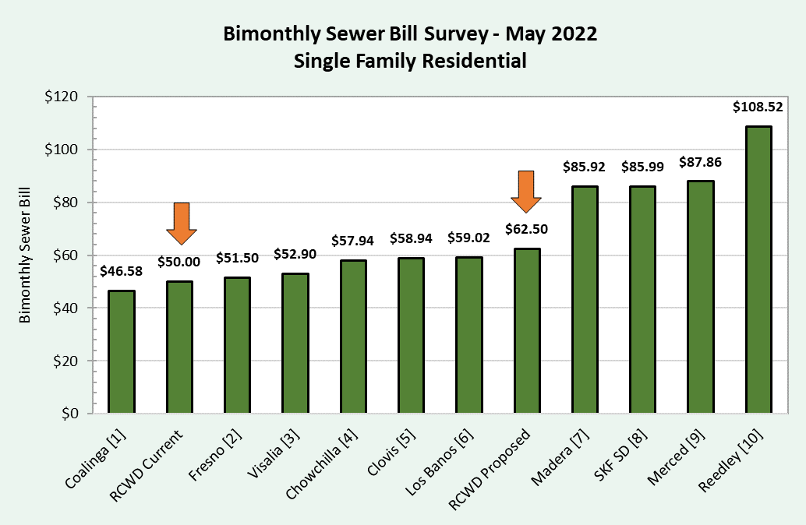

[1] Rate shown is planned to take effect 11/1/2022 based on rate schedule approved 11/1/2020
[2] Rates effective 7/1/2021
[3] Rates effective 7/1/2021
[4] Rate shown is proposed for FY 2023 based on most recent rate study dated April 22, 2020
[5] Rates effective 7/1/2021
[6] Rates effective 7/1/2021
[7] Rate shown is proposed for FY 2023 but not yet approved. Proposed rates will be voted on at Prop 218 Hearing scheduled for June 15, 2022
[8] Rate shown is based on rates approved for Selma residents for FY 2023
[9] Rates effective as of February 2022
[10] Rates effective 7/1/2021

Storm Drain Rates
The purpose of the storm drain system is to collect runoff during wet weather events to prevent flooding. Storm drain infrastructure consists of tributaries and catchment basins to collect and store runoff. Captured stormwater is retained and percolates into the groundwater basin. This function has relatively low operating costs in comparison to the municipal water system (water purchase costs) and the wastewater system (treatment costs).

Storm Drain Cash Flow Projection
The cash flow for the storm drain service is provided in Table 16. Most cost categories are projected to increase by 3% annually. Repairs, maintenance, and mowing expenses are projected to increase proportionally based on customer growth. The MS4 Program cost is for the development of a stormwater pollution prevention plan. Once the plan is complete, RCWD expects ongoing costs for compliance and/or development of additional programs.
2022 through 2025, it is proposed that the storm drain rates increase 25% each year followed by a 15% rate increase in 2026. The first rate increase is proposed to go into effect September 1, 2022, with subsequent rate increases going into effect January 1 of each year thereafter. Similar to the other utilities, the storm drain utility is projected to operate at a deficit through 2023. The total debt of the storm drain utility is expected to increase to a high of about $270,000 which is projected to be fully repaid by the end of 2026.

Table 16: Storm Drain Operating Cash Flow
2022 Municipal Rate Study Update
Root Creek Water District
 | 2022 | 2023 | 2024 | 2025 | 2026
 | 1-Sep | 1-Jan | 1-Jan | 1-Jan | 1-Jan
% Rate Increase | 25% | 25% | 25% | 25% | 15%
Bimonthly Bill ($/EDU) | $8.95 | $11.19 | $13.99 | $17.49 | $20.11
BEGINNING FUND BALANCE | (123,300) | (234,800) | (271,000) | (253,800) | (163,500)
REVENUES
Rate Revenue | 45,400 | 117,400 | 186,200 | 274,700 | 364,100
Inspection Fees | 117,000 | 117,000 | 117,000 | 117,000 | 117,000
TOTAL REVENUES | 162,400 | 234,400 | 303,200 | 391,700 | 481,100
EXPENSES
Operator | 20,100 | 20,700 | 21,300 | 21,900 | 22,600
Inspections | 112,300 | 115,700 | 119,200 | 122,800 | 126,500
Professional Services | 62,500 | 64,400 | 66,300 | 68,300 | 70,300
Rate Study & Financial Planning | 19,000 | 0 | 0 | 0 | 0
Engineering & Master Planning | 20,000 | 20,600 | 21,200 | 21,800 | 22,500
MS4 Program/Future Programs | 15,000 | 15,500 | 16,000 | 16,500 | 17,000
Repairs | 10,000 | 12,700 | 16,100 | 19,000 | 21,900
Maintenance & Mowing | 15,000 | 21,000 | 25,900 | 31,100 | 36,600
Total Operations | 273,900 | 270,600 | 286,000 | 301,400 | 317,400
NET REVENUES | (111,500) | (36,200) | 17,200 | 90,300 | 163,700
ENDING FUND BALANCE | (234,800) | (271,000) | (253,800) | (163,500) | 200

Storm Drain Rate Design
Storm drain operating costs are currently collected per EDU based on the runoff of a medium density single family parcel of 1/5 acre. The storm drain operating fees for other parcel sizes and land uses are scaled based on acreage and impervious surface area as described in the 2021 Connection Fee Update page 23. On September 1, 2022, it is proposed that the bimonthly storm drain rate increase from $7.16 to $8.95.

Proposed Municipal Rates and Operating Results

Proposed Municipal Rates
Table 17 shows the current and proposed municipal rates for water, sewer, and storm drain service. A typical single family customer in Riverstone is assumed to reside on a 1/5 acre lot, be served by up to a 1 ½-inch water meter, and consume 25 CCF of water during each bimonthly billing period. For this typical customer, the combined bimonthly equivalent assessment, water, sewer, and storm drain bill is proposed to increase from $138.15 to $172.98 on September 1, 2022. Table 18 shows proposed municipal volume rates under drought conditions. Under drought conditions, it is proposed that all customers be assessed the residential tier 2 volume rate for all usage.

Table 17: Current and Proposed Municipal Bimonthly Rates
2022 Municipal Rate Study Update
Root Creek Water District
Category | January 1, 2022 Current | September 1, 2022 | January 1, 2023 | January 1, 2024 | January 1, 2025 | January 1, 2026
Municipal Water Service
Residential Volume Rates ($/CCF)
Tier 1: 0 to 20 CCF | $1.55 | $1.98 | $2.48 | $3.10 | $3.35 | $3.62
Tier 2: over 20 CCF | $2.18 | $2.91 | $3.64 | $4.55 | $4.91 | $5.30
Non-residential Volume Rate ($/CCF)
Commercial |  | $2.32 | $2.90 | $3.63 | $3.92 | $4.23
Irrigation |  | $2.37 | $2.96 | $3.70 | $4.00 | $4.32
Meter Fees
1" | $37.90 | $47.38 | $59.23 | $74.04 | $79.96 | $86.36
1.5" | $37.90 | $47.38 | $59.23 | $74.04 | $79.96 | $86.36
2" | $59.44 | $75.81 | $94.77 | $118.46 | $127.94 | $138.18
3" | $116.74 | $151.62 | $189.54 | $236.93 | $255.87 | $276.35
4" | $181.22 | $236.90 | $296.15 | $370.20 | $399.80 | $431.80
6" | $360.34 | $473.80 | $592.30 | $740.40 | $799.60 | $863.60
Municipal Sewer Service
Per Dwelling Unit | $50.00 | $62.50 | $78.13 | $97.66 | $117.19 | $140.63
Municipal Storm Drain Service
Per Dwelling Unit | $7.16 | $8.95 | $11.19 | $13.99 | $17.49 | $20.11
Assessment ($/acre/year) | $35.81 | No longer billed – incorporated into water rates shown above

Table 18: Proposed Bimonthly Volume Rates – Drought Conditions
2022 Municipal Rate Study Update
Root Creek Water District
Category | September 1, 2022 | January 1, 2023 | January 1, 2024 | January 1, 2025 | January 1, 2026
Municipal Water Volume Rates ($/CCF) – Drought Conditions
Residential | $2.91 | $3.64 | $4.55 | $4.91 | $5.30
Commercial | $2.91 | $3.64 | $4.55 | $4.91 | $5.30
Irrigation | $2.91 | $3.64 | $4.55 | $4.91 | $5.30

Figure 8 compares RCWD’s current and proposed combined water and sewer bill for a typical single family residential customer with the corresponding rates charged by other local agencies. Storm drain fees are not included in the bill survey as most local public agencies do not charge storm drain fees on the utility bill.

Figure 8: Bimonthly Utility Bill Survey - Water and Sewer

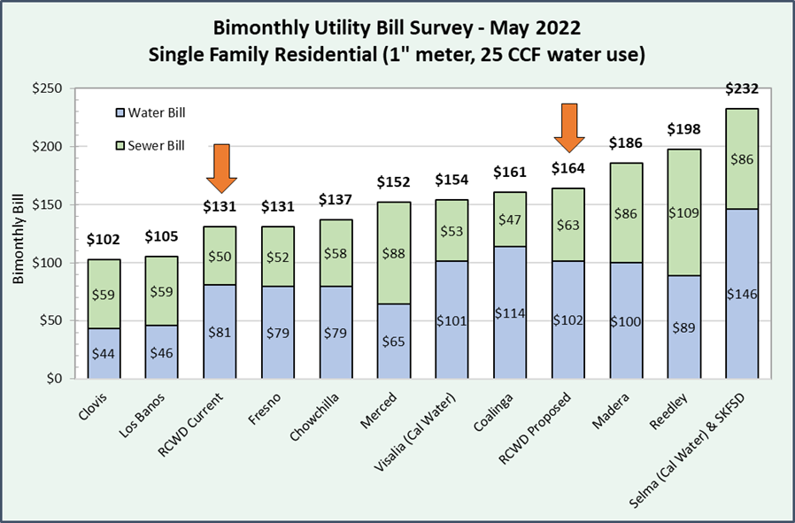
Please see Figure 5 and Figure 7 for more detailed rate information of the comparable agencies.
Figure 9 provides a survey comparing the current and proposed water and sewer bills of the Root Creek Water District to the Cities of Fresno and Clovis. The Fresno and Clovis bills are based on average per capita water usage and household size for those communities.

Figure 9: Bimonthly Utility Bill Survey Based on Community Characteristics

[1] Rate shown is based on bimonthly water use of 27 thousand gallons (36.2 CCF). According to 2021 data from the State Water Resources Control Board, average residential daily usage per capita is 149.58 gallons per day in the City of Clovis, which equates to 12.2 CCF bimonthly. Based on 2020 Census data, the average household size is 2.97 people per home in Clovis, meaning usage per household is approximately 36.2 CCF bimonthly.
[2] Rate shown is based on bimonthly water use of 25 CCF.
[3] Rate shown is based on bimonthly water use of 31 CCF. According to 2021 data from the State Water Resources Control Board, average residential daily usage per capita is 126.36 gallons per day in the City of Fresno, which equates to 10.3 CCF bimonthly. Based on 2020 Census data, average household size in Fresno is 3.04 people per home, meaning usage per household is approximately 31 CCF bimonthly.

Operating Results
Based on the proposed rate increases, the combined water, sewer, and storm drain cash flows are summarized in Table 19 and Figure 10. From 2022 to 2023, the total municipal debt is projected to increase by about $2.84 million from about $5.72 million to about $8.56 million. 2024 to 2026, the debt is projected to be paid down by about $3.15 million resulting in an ending balance of about $5.41 million. However, these amounts do not factor in interest expenses.

Table 19: Municipal Operating Results
2022 Municipal Rate Study Update
Root Creek Water District
 | 2022 | 2023 | 2024 | 2025 | 2026
Total Beginning Fund Balance | (5,721,600) | (7,780,400) | (8,561,300) | (8,430,400) | (7,468,800)
Water | (4,456,300) | (5,418,800) | (5,911,300) | (5,828,800) | (5,355,800)
Sewer | (1,142,000) | (2,126,800) | (2,379,000) | (2,347,800) | (1,949,500)
Storm Drain | (123,300) | (234,800) | (271,000) | (253,800) | (163,500)
Total Ending  Fund Balance | (7,780,400) | (8,561,300) | (8,430,400) | (7,468,800) | (5,410,800)
Water | (5,418,800) | (5,911,300) | (5,828,800) | (5,355,800) | (4,408,300)
Sewer | (2,126,800) | (2,379,000) | (2,347,800) | (1,949,500) | (1,002,700)
Storm Drain | (234,800) | (271,000) | (253,800) | (163,500) | 200
 |  |  |  |  |  | 5-Year Total
Repayment of Operating Deficit | $0 | $0 | $130,900 | $961,600 | $2,058,000 | $3,150,500
Water | $0 | $0 | $82,500 | $473,000 | $947,500 | $1,503,000
Sewer | $0 | $0 | $31,200 | $398,300 | $946,800 | $1,376,300
Storm Drain | $0 | $0 | $17,200 | $90,300 | $163,700 | $271,200

Figure 10: Municipal Operating Debt

